Product Functions

One of the biggest strengths of our project is the plethora of advanced features. For instance, our Road Management Software contains an image processing feature, in which users can take photos of problems they find on the streets to upload them on the app’s feed. Add to this, our software contains a Chat-Bot feature in which the user can ask the integrated AI any inquiries he/she has and the bot will respond immediately with utmost accuracy. Other features include a user friendly user interface in which anyone can navigate through without any trouble. The colors chosen for the app’s design make all info posted clear and nice to read. Furthermore, a search tool can be found at the bottom of the app to look for any specific municipality you want to inquire about. The app’s feed makes reading and interpreting posts from other users very clear to understand. Overall, there are no shortage of features in our software which makes our system a very helpful and fruitful app for problems related to city’s roads.

User Characteristics:

The target audience for the Road Management System is mainly drivers and generally citizens. It is meant to aid people driving to experience better road quality during their travels. Moreover, every driver is required to have a license and registration papers. Add to this, users must know the areas the app covers to have a deeper understanding on where the problems are located. Hence, our target users will be people (mainly Lebanese) aiming to make street environment safer and cleaner.

Database Flow Diagram

DFD gives a general idea of where the data flows in our project. From data storages to other processes. In our level 0 DFD, the only process to be indicated is the software itself as one process. However, when we zoom in to level 1 of our DFD, we can see that many new processes arise. For example, the search of users, the processing of reports, validation of reports… etc. Below is the DFD for both levels:

DFD Level 0:

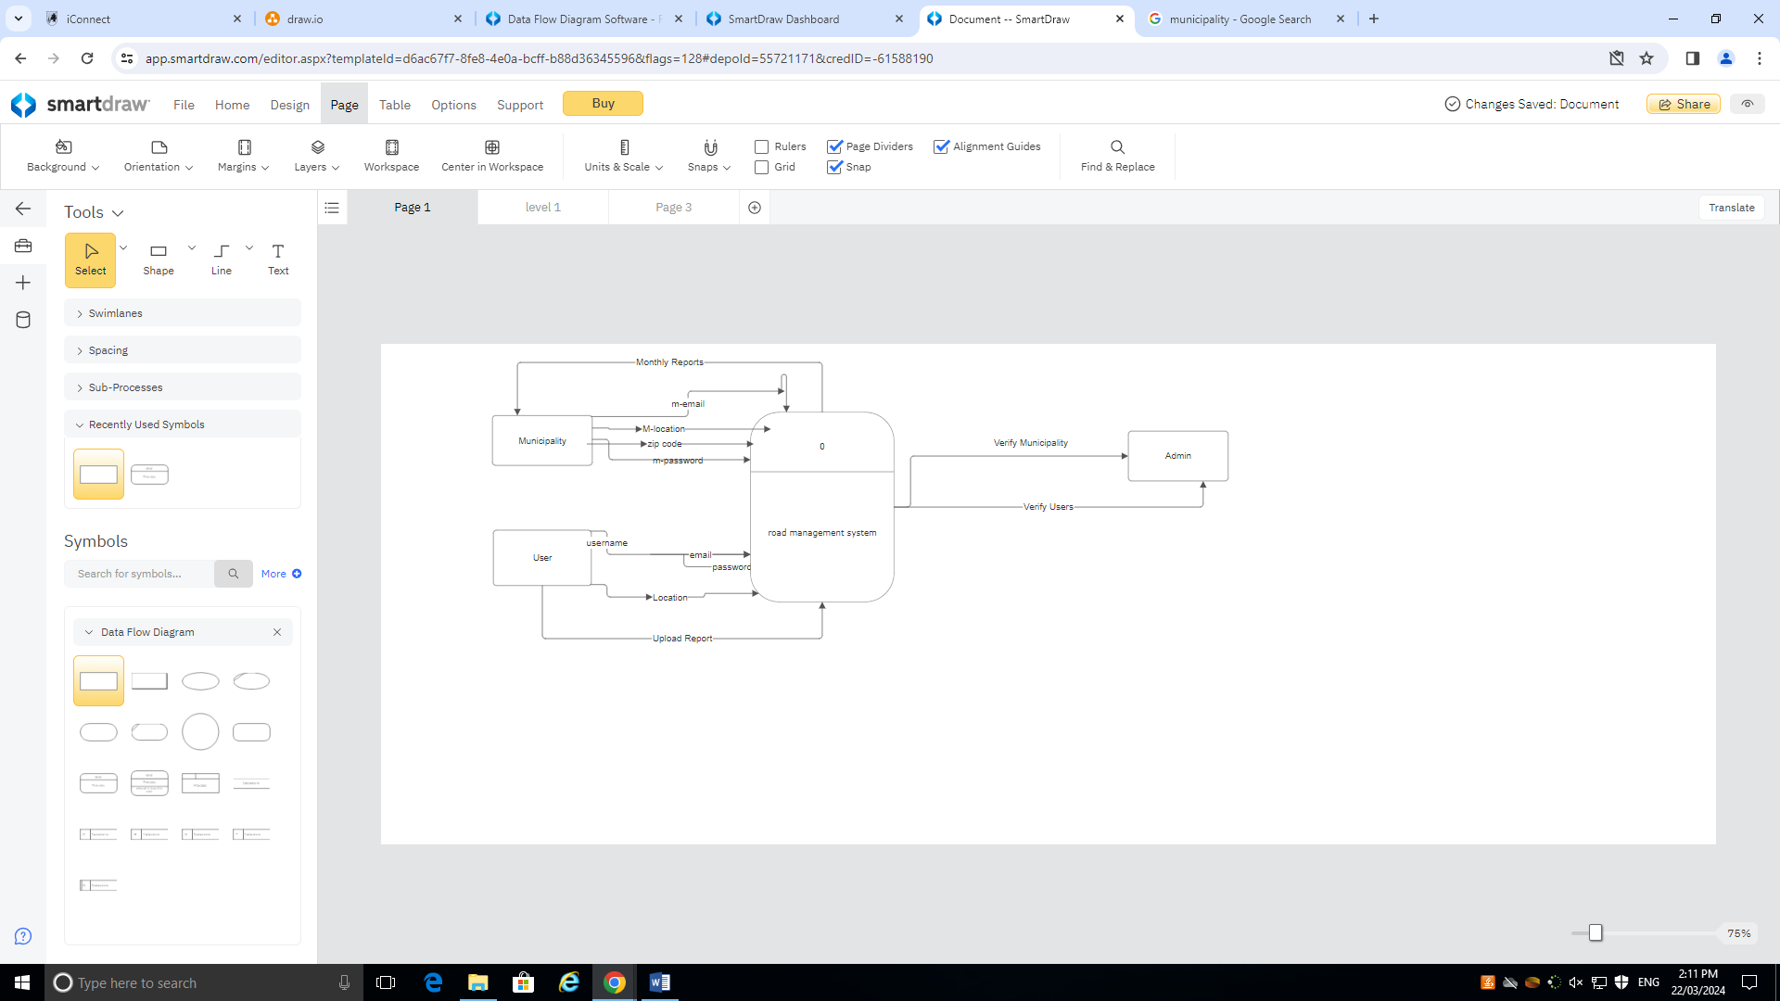

DFD Level 1:

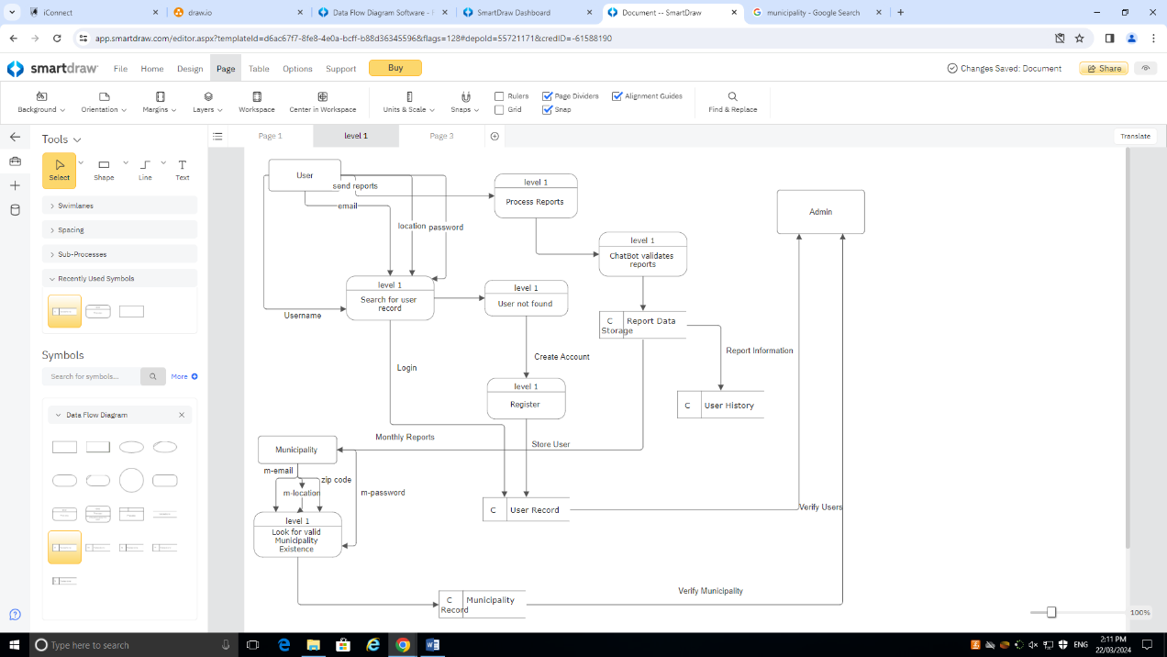

Sequence Diagram

In this diagram, the lifeline of both the Road Management Application and the Municipality remain consistent throughout all sequences found in our software. Below is the sequence diagram:

